PDS

Livrable De R3

Banhakeia Ali

Manuel utilisateur :

Description:

The Staff can consult the list of all the purchases by a simple click on the Button SELECT, it can also consult the list of all the purchases of a customer starting from his name and first name by a simple click on the same Button SELECT and at the same time, he can see the customer profile and more precisely the percentage of each profile favored by the customer from the number of orders and the price consumed by the customer. Detailed description:

The identification view:

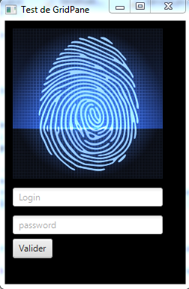

The Main View allows staff to see all purchases by displaying first name, last name, product name, product purchase date, online or on-site payment method, and product profile and product price. by a simple click on the Select button

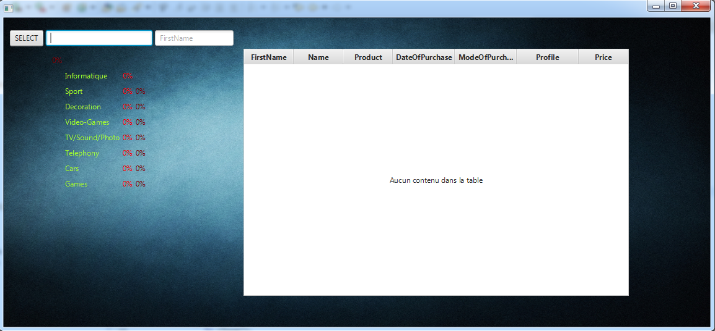

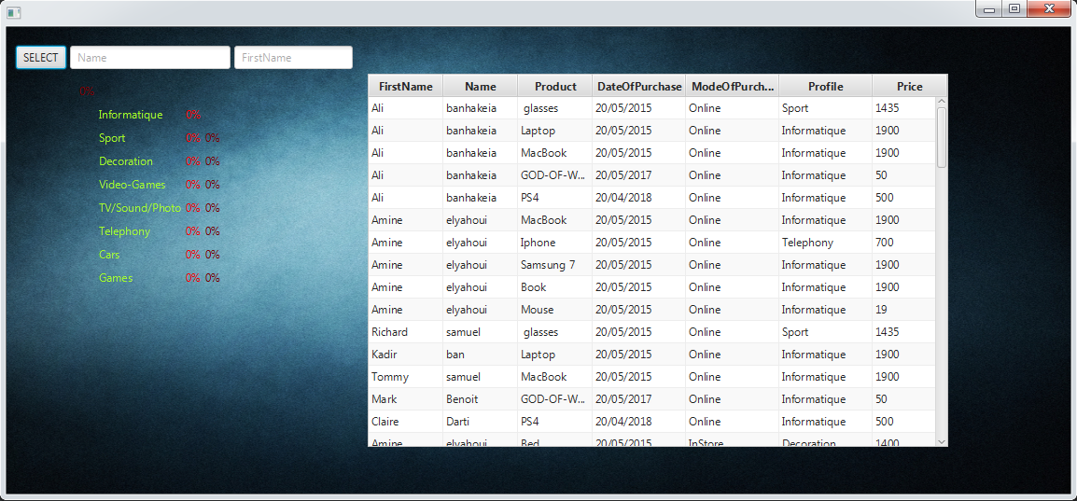

The program allows us to congratulate the task to find the names and first names of the customer by automatically displaying a list of names that to the words written and displayed each time the client clicks on a keyboard key.

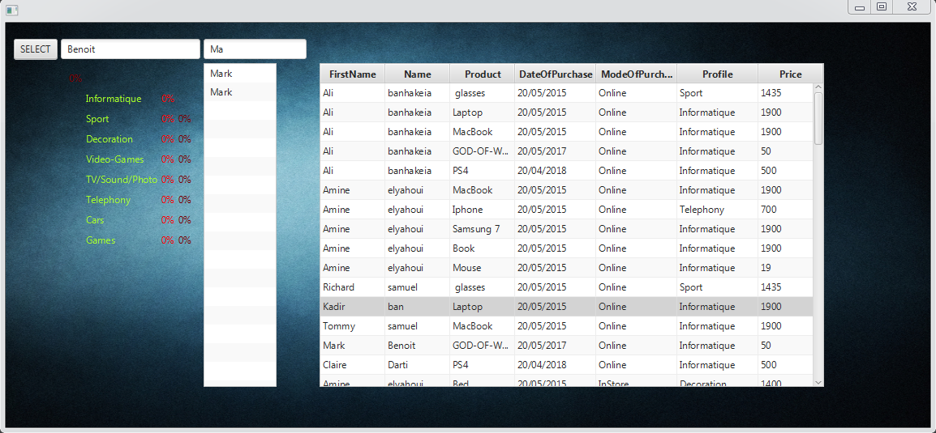

Staff can see the percentage in each profile by putting the customer's first and last name and a single click on the Select Button

